SOMERSAULT
September 2017
Vol 40, No 5
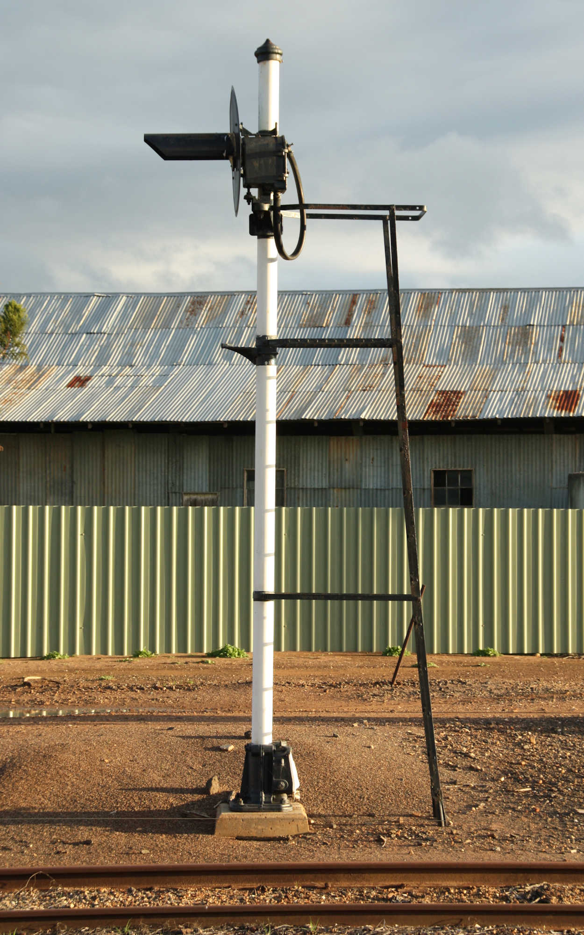
Signalling Record Society of Victoria

Society Contact Information
(Front cover). The light Down Home signal at Bridgewater was provided on 31 July 1975 when the flashing lights were provided at Lyndhurst Street. McKenzie and Holland had a good business at this time installing flashing lights at country locations, and these searchlight signals were commonly installed to protect the level crossings. The detailing of the mast is largely due to McKenzie & Holland – that is to say, Westinghouse Brake & Signal in the UK, and, behind them, Union Switch and Signal in the US. Proprietary details include the finial (which always reminds me of a Chocolate Royale), the mast base, and, above all, the searchlight head and DC searchlight mechanism. Once common, these signals are becoming rare as conventionally signalled locations are abolished. More photos of Bridgewater can be found starting from page 88. Photo Andrew Waugh
Published by the Signalling Record Society Victoria Inc (A0024029F)
EDITOR: Andrew Waugh, 28 Amelia St McKinnon, VIC, 3204
Phone (03) 9578 2867 (AH), (03) 9348 5724 (BH), email andrew.waugh@gmail.com
PRESIDENT: David Langley, P.O. Box 8, Avenel, VIC, 3664, Phone (03) 5796 2337
SECRETARY and MEMBERSHIP OFFICER: Glenn Cumming,
Unit 1/4-6 Keogh St, Burwood, VIC 3125. Phone (03) 9808 0649 (AH)
NSW CONTACT: Bob Taaffe, 63 Hillcrest Rd, Tolmans Hill, TAS, 7007, Phone: (03) 6223 1626
QUEENSLAND CONTACT: Phil Barker
PO Box 326, Samford, QLD, 4520, Phone: (07) 3289 7177, email: signal-1@bigpond.com
Unless articles use copyrighted information, articles may be reprinted without prior permission but acknowledgment is required. Opinions expressed in articles appearing in SOMERSAULT or supplements are not necessarily those of the S.R.S.V. (Inc.)

Signalling Alterations
The following alterations were published in WN 28/17 to WN 34/17, and ETRB A circulars. The alterations have been edited to conserve space. Dates in parenthesis are the dates of publication, which may not be the date of the alterations.
(04.07.2017) Mildura – Yelta (SW 81/2017, WN 27)
Signalling Diagram 28/16 (Mildura – Yelta) replaced 26/10 as in service. The alterations are the provision of a pedestrian crossing at Mildura station, and the removal of the redundant push buttons at Mildura to operate the flashing lights at Chaffey St.
11.07.2017 Lilydale (SW 221/17, WN 29)
On Tuesday, 11.7., Points 207 were booked back into service.
15.07.2017 Dandenong (SW 197/17, WN 27)
Between Thursday, 6.7., and Saturday, 15.7., the following trackwork will be installed:
- A facing crossover between the Up and Down Pakenham lines between 32.612 km and 32.725 km near Post DNG749
- A trailing turnout in the Up Pakenham line at 32.741 km for the future Down Cranbourne line
- A turnout in the single Cranbourne line at 34.574 km on the Up side of Greens Road.
These points will not be commissioned and will be secured normal.
16.07.2017 Long Island (SW 211/17, WN 29)
From Saturday, 16.7., until Thursday, 3.8., track machines are permitted to stable in the booked out track leading to the Cresco Sidings.
17.07.2017 North Dynon (SW /17, WN 28)
On Monday, 17.7., the following alterations took place.
- No 6 Track was slewed to connect with No 5 Track. Points VTD72 were provided.
- No 7 Track was extended to connect with No 6 Track. Points VTD73 were provided.
- The connection from No 7 Track towards No 9 Track was abolished and points VTD43 were secured.
- Points VTD73 were provided with a gauge indicating banner which will display ‘SG’ when the points are set for No 6 Track, and ‘DG’ when the points are set for No 7 Track.
- Points VTD4 (No 5 Track to No 3 Track) are provided with a gauge indicating banner which will display ‘SG’ when the points are set for No 3 Track, and ‘DG’ when the points are along No 5 Track.
- A ‘Limit of Standard Gauge Shunt’ is provided at the end of the dual gauge portion of No 9 Track.
Amend Diagram 37/14 (South Kensington)
(18.07.2017) Murchison East (SW 89/17, WN 29)
Operating Procedure 106 (Murchison East) was issued.
18.07.2017 Newport (SW 208/17, WN 29)
On Tuesday, 18.7., Points 612 were equipped with a M23A dual control point machine. The selector lever was secured with a signal maintenance padlock.
19.07.2017 Newport (SW 208/17, WN 29)
On Wednesday, 19.7., Points 609 were equipped with a M23A dual control point machine. The selector lever was secured with a signal maintenance padlock.
20.07.2017 Frankston (SW 224/17, WN 30)
On Thursday, 20.7., Points 25U were secured normal by point clips locked with 5P padlocks. If it is necessary to operate these points, they must be clipped and locked for each movement to ensure the point blades are closed and secured. At the completion of the movement, the points must be secured normal.
22.07.2017 Cowangie, Murrayville, Panitya (SW 92/17, WN 29)
On Saturday, 22.7., Cowangie was closed as a staff station, and the sections Ouyen – Cowangie and Cowangie – Panitya were withdrawn. The new Train Staff & Ticket section will be Ouyen – Murrayville, however Ticket Boxes will not be supplied and all trains must operate using the Train Staff. SW184/09 was cancelled.
The line beyond Murrayville is booked out due to the condition of the track. Baulks have been provided on the Down side of Murrayville at 581.500 km.
(25.07.2017) Book of Rules, Section 4, Rule 3e (Trailing Points: Defective Home Signal at Stop (SW 94/17, WN 30)
This clause is amended on the V Line Network.
If the defective Home reads over facing or trailing points, or the fouling point of a crossover, the Driver must be issued with a Caution Order to pass the signal. An order may only be issued when the track section ahead is clear (in the case of a Block section, the Block section must be clear). The Signaller may not issue more than one Caution Order for the same signal at a time, and a Caution Order may only cover one signal. Caution Orders are only to be issued for signals when the train arrives at that signal. The Hand Signaller must ensure the trailing points are in the correct position for the train. The S&C department must be informed of the fault.
30.07.2017 Bendigo (SW 95/17, WN 30)
On Monday, 30.7., the sidings were altered.
- The sidings to the Vehicle Maintenance Shed have been abolished.
- Two new stabling sidings, Nos 7 & 8, have been provided on the Up side of the former Vehicle Maintenance Shed. These have a standing room of 161 metres.
- The existing sidings Nos 7, 8, & 9 have been renumbered 9, 10, & 11. Buffers have been provided at the end of these sidings.
- Access to Nos 8, 9, 10, & 11 Sidings is by a new set of points from the Independent track which are on the Up side of the former points. Movements from these sidings is governed by Stop Board No 3.
- Access to No 7 Siding is by the set of points that formerly led to the (now) Sidings 9, 10, & 11. Movement from this siding is governed by Stop Board No 2.
- Sleeper mounted signs have been provided showing the siding road numbers for arriving trains and the clearance points for departing trains.
- Sidings 7 & 8 are not available for use and the points have been secured away from the siding.
Amend Diagram 34/16 (Bendigo).
31.07.2017 Bendigo (SW 96/17, WN 30)
Effective Monday, 31.7., Operating Procedure 117 (Bendigo Local Movement) was amended. This covers changes to the Stabling sidings and Stop Boards due to the track work changes described on SW 95/17. SW 2/17 was cancelled.
07.08.2017 Dunolly – Yelta, Ouyen – Murrayville, Ararat – Maryborough (SW 100/17, WN 32)
At 0700 hours, Monday, 7.8., Absolute Occupations were granted over the Dunolly – Yelta, and Ouyen – Murrayville lines for gauge conversion. An Absolute Occupation was granted over the Ararat – Maryborough line for remediation work.
At Dunolly, Points DLY29 were secured reverse for the Inglewood line. Home DLY36 was secured at Stop. Baulks or track closure devices were placed at DLY26.
At Yelta, baulks or track closure devices were placed at the Train Order Territory Boards
At Murrayville, baulks or track closure devices were placed at the Up end points.
The Train Staff for the Ouyen – Murrayville section will be temporarily withdrawn.
All fixed signals within the Absolute Occupation will remain in use and must be observed by any movement.
07.08.2017 Dunolly (SW 101/17 & 103/17, WN 32)
On Monday, 7.8., Nos 3, 4, & 5 Roads were abolished and the tracks will be removed.
Nos 1 & 2 Roads will remain in use as a Trailable Point loop. The signalling was altered and fixed in the unattended mode. The Annett locks securing the hand operating levers on Points DLY7 & DLY27 were removed. The key switches at Points DLY27 were abolished.
The junction points DLY29 were secured reverse for the Inglewood line. Homes DLY26 and DLY36 were secured at stop. The key switches for the route setting of Homes DLY28 and DLY38 will remain in service.
Points A, E, F, and G (leading to Nos 3 and 4 Roads) were secured normal and the Annett locks removed.
Points H (leading to Siding D at the Down end end) were secured normal and the Annett Lock was removed. The non-trailable point machines on Points D and J in Siding D were abolished.
The ST21, E, and F pattern Annett locks and Annett keys on the platform were abolished. The Signallers keyswitch box was placed out of use and secured by a signal maintenance padlock.
Home DLY6 will normally be at proceed with all the other signals at stop.
A Down train can be issued with a Train Order to proceed to Dunolly or through Dunolly to the Inglewood line. The text of the Train Order for the train to depart Dunolly will include instructions for the driver to operate Home DLY38 from the Driver’s key switch box opposite the station office. Home DLY38 will automatically return to stop as the train passes it.
An Up train can be issued with a Train Order to proceed to Dunolly or though Dunolly to Maryborough. Trains are not permitted to be held at DLY28. If a conflicting move means that a Train Order cannot be issued into Dunolly, the train must be held at Arnold Block Point. The text of the Train Order for the train to arrive into Dunolly will include instructions for the driver to operate Home DLY28 from the Driver’s key switch box at the Home. The signal will clear when the flashing lights at Broadway are operating. Home DLY28 will automatically return to stop as the train passes it.
Amend Diagram 70/13 (Dunolly).
Operating Procedure 84 (Dunolly) was reissued. SW 77/14 was cancelled.
07.08.2017 Manangatang (SW 102/17, WN 32)
On Monday, 7.8., the following alterations were made:
- The two position Up Automatic protecting the Mallee Highway was altered to normally display Stop. The Automatic signal is operated by the existing V5PSW key switches opposite the signal and at the Up end points. Indicating lights are provided at each key switch to indicate that the Active Advance Warning equipment on the Mallee Highway is operating.
- The Annett lock on the Up end points was abolished, together with the Duplex lock (Master/Annett Key Exchange).
- The Master Key lock on the Down end points was abolished.
- The Down end yard limits have been extended from 457.275 km to 460.300 km and the baulks relocated to match. The maximum speed between Doondah Rd (457.275 km) and the baulks is 25 km/h.
When the Automatic signal is at Stop, movements can be made within Manangatang yard without operating the boom barriers. When it is necessary to enter the level crossing, the Automatic signal is to be cleared from a key switch. The Automatic signal will clear when the boom barriers are horizontal and will automatically be restored to stop by the passage of the train.
The boom barriers will operate automatically for a Down movement.
Amend Diagram 148/11 (Chinkapook – Annuello).
07.08.2017 Highett – Cheltenham (SW 217/17, WN 31)
On Monday, 7.8., Automatics F622 & F627 were replaced by new masts with LED heads.
In addition, the wiring behind the Cheltenham panel will be altered to facilitate future work. Circuit changes were made in the control of Points 7 & 11 to correct an issue. The 1KVA transformers in the signalling power supply at locations F644F and F622F were replaced with 3KVA transformers.
08.08.2017 Maryborough (SW 105/17, WN 32)
On Tuesday, 8.8., Nos 3 – 9 Roads, the Shed Road, and the Up end extensions of Nos 8 & 9 Roads were abolished. Stop Boards A and B were abolished. Points MYB5 (Down end) and MYB9 (Up end) were secured normal.
Nos 1 & 2 Roads at Maryborough are running roads. Trains are not permitted to be stabled or left unattended on Nos 1 or 2 Roads.
Amend Diagram 152/12 (Maryborough).
09.08.2017 ICE Radio Implementation (SW 99/17, WN 32)
At 0001 hours Wednesday, 9.8., the following lines were converted to ICE radio and the existing NUTR base stations were abolished:
- Seymour – Shepparton
- Toolamba – Echuca
- Epsom – Echuca
- Eaglehawk - Piangil
11.08.2017 Beulah (TON 67/17, WN 32)
On Friday, 11.8., Beulah yard (383.895 km – 384.168 km) was booked back into service.
12.08.2017 Ringwood East – Mooroolbark (SW 233/17, WN 33)
On Saturday, 12.8., Automatics H942, H966, and H1016, were converted to tri-colour LED lights.
13.08.2017 Regional Rail Communications Network (SW 227/17 & 97/17, ARTC TN 1338/17, WN 32)
On Sunday, 13.8., the Regional Rail Communications Network (RRCN) will be reconfigured due to the commissioning of the Voice Communications System (VCS) console in Metrol.
After this reconfiguration, all ‘Controller’ and ‘Emergency’ calls initiated from the ICE radios will be automatically routed to the controlling train control centre (Metrol, Centrol, ARTC Mile End, or ARTC Junee). Where a movement is operating on a corridor managed by Metrol, the ICE radio will display ‘MTL’, by Centrol ‘VIC’, by Mile End ‘ADL’, and by Junee ‘JUE’.
Metrol will be able to see trains outside the area it controls via the VCS, and be able to initiate calls to these trains.
Where an incident affects parallel lines near a train control boundary, authority has been given to the control centre that receives the first advice of an incident to stop all movements, whether on their corridor or not. When the incident has been cleared, the control centre that initiated the stop will inform the other control centres. Each control centre will then grant permission for movements on their corridors to resume.
(15.08.2017) Frankston – Stony Point (SW 241/17, WN 33)
Single unit Sprinter DMU are now permitted to operate between Frankston & Stony Point. SW 212/17 is cancelled.
15.08.2017 Stratford (SW 106/17, WN 33)
On and from Tuesday, 15.8., Sandhill Road level crossing (223.961 km) was closed to road traffic. The passive road signs, roadway, and whistle boards were abolished, and road barriers provided. Amend Diagram 14/15 (Stratford – Hillside).
16.08.2017 Maryborough (TON 69, WN 34)
On Wednesday, 16.8., Nos 2, 3, & 4 Roads at Maryborough Loco were booked back into service for short term stabling purposes. They cannot be used for fueling.
17.08.2017 Westona (SW 219/17, WN 30)
On Friday, 18.8., the existing pedestrian boom barriers at Maidstone Street were replaced by automatic pedestrian gates. An additional two automatic pedestrian gates were provided on the Down side of the roadway in the island between the tracks. Magnetically latched emergency exit gates were provided. Flashing light mast No 16 was relocated and the incandescent flashing lights were replaced by LED units.
Amend Diagram 43/10 (Altona Junction – Westona – Laverton).
19.08.2017 Caulfield (SW 243/17, WN 34)
On Saturday, 19.8., the Works Siding was abolished (it had been previously booked out of service). Points 610D were secured normal
20.08.2017 Wallan (SW 107/17, WN 33)
Between Saturday, 19.8., and Sunday, 20.8., Up Home Post 6 was converted to a LED signal.
20.08.2017 Broadford (SW 107/17, WN 33)
Between Saturday, 19.8., and Sunday, 20.8., the incandescent lamps on Posts 7 (Down Home), 16 (Down Starting), 17 (Up Home), 18 (Up Home), and 19 (Up Distant) were replaced by LED lamp units.
22.08.2017 Sherwood Park (SW 108/17, WN 33)
On Tuesday, 22.8., boom barriers were provided at the passive level crossing at Rowans Lane (260.321 km). Operation is by axle counters. Healthy State indicators, Yellow Whistle Boards, and remote monitoring equipment were provided. Amend Diagram 48/14 (Panmure – Sherwood Park).
22.08.2017 Bendigo (SW 112/17, TON 76/17, WN 35)
On Tuesday, 22.8., Nos 7 & 8 Sidings (SW 95/17) were brought into use. Amend Diagram 34/16 (Bendigo).
23.08.2017 Cudgee (SW 109/17, WN 33)
On Wednesday, 23.8., boom barriers were provided at the passive level crossing at Hallowells Road (249.386 km). Operation will be by axle counters. Healthy State indicators, Yellow Whistle Boards, and remote monitoring equipment were provided. Amend Diagram 48/14 (Panmure – Sherwood Park).
24.08.2017 Panmure (SW 110/17, WN 33)
On Thursday, 24.8., boom barriers were provided at the passive level crossing at Station Street (242.747 km). Operation will be by axle counters. Healthy State indicators, Yellow Whistle Boards, and remote monitoring equipment were provided. Amend Diagram 48/14 (Panmure – Sherwood Park).
25.08.2017 Winchelsea (SW 111/17, WN 33)
On Friday, 25.8., boom barriers were provided at the passive level crossing at Robertson Road (120.362 km). Operation will be by axle counters. Healthy State indicators, Yellow Whistle Boards, and remote monitoring equipment were provided. Note that the previous location of this crossing (120.300 km) was incorrect. Amend Diagram 96/14 (Moriac - Winchelsea).
25.08.2017 Bendigo – Echuca (TON 75/17, WN 35)
On Friday, 25.8., the wheel contamination inspections were cancelled. This includes the wheel inspection at Home BG026, wheel clearing at Echuca, and the scrubbing of approaches at Powell St, Heinz St, and Murray Valley Highway (all at Echuca).
25.08.2017 Murchison East (TON 77/17, WN 35)
On Friday, 25.8., Nos 3 & 4 Roads (147.038 km – 147.409 km) were booked out of service due to poor sleeper condition. The points leading to No 3 Road have been secured to lie for No 2 Rd.
27.08.2017 Ballarat – Ararat (SW 115/17, WN 35)
Effective Sunday, 27.8., Operating Procedure 70 (Ballarat – Ararat Staff Working) was reissued. The principle alteration are updated references for the attendance of the Signaller responsible for the management of the Train Staff & Ticket section Wendouree – Ararat. SW 110/16 is cancelled.
27.08.2017 Ararat (SW 116/17, WN 35)
Effective Sunday, 27.8., Operating Procedure 82 (Ararat) was reissued. The principle alteration are updated references for the attendance of the Signaller responsible for the management of the Train Staff & Ticket section Wendouree – Ararat. SW 6/16 is cancelled.
28.08.2017 Carrum (SW 253/17, WN 35)
On Tuesday, 29.8., the Carrum control panel and the signal maintenance mimic panel will be altered to display indications for track circuits F1218T and F1236T.
(29.08.2017) Moriac – Winchelsea (SW 117/17, WN 35)
Diagram 24/17 (Moriac – Winchelsea) replaced 96/14 as in service. The principle alterations are level crossing upgrades.
(29.08.2017) Panmure – Sherwood Park (SW 114/17, WN 35)
Diagram 49/17 (Panmure – Sherwood Park) replaced 48/14 as in service. The principle alterations are level crossing upgrades.
(29.08.2017) Maryborough (SW 120/17, WN 35)
Effective forthwith, Operating Procedure 80 (Maryborough) was reissued. Operating Procedures 79 (Master Key Releasing Box) and 81 (Maryborough Locomotive Depot Sidings) were cancelled, and the contents were included in Operating Procedure 80. In addition, the revised Operating Procedure reflects the abolition of Maryborough yard tracks. SW 128/13 (Operating Procedures 79, 80, & 81) was cancelled.
31.08.2017 ICE Radio (SW 113/17, WN 35)
At 0001 hours on Thursday, 31.8., the final stage for implementation of the ICE communications system will take place.
Communication with V/Line Train Control will be by ICE radios. All remaining NUTR base stations will be taken out of service.
End£

Ballarat

Early days
As described in the history of Ballarat East, the formal opening of the railway line to Ballarat was on 10 April 1862, with public passenger and parcels traffic commencing the following day. Goods traffic commenced when the line was duplicated on 20 August 1862.
From the start, Ballarat was served by two stations: Ballarat and Ballarat East. These two stations were separated by a large embankment across the Yarrowee River valley. At this time, there was only two lines across the embankment. The passenger station was where it is today, and the current train shed existed – perhaps the frequently less than clement Ballarat weather was responsible for its provision. The train shed covered two platforms. The station offices were on the northern platform, now Platform 2, and, again, still exist today. It is likely that the southern platform (the current Platform 1) was the arrival platform, and the northern platform, with the passenger facilities, was the departure platform. The goods yard at Ballarat was, as it remained, to the north of the passenger station, and its centrepiece was the large goods shed that still exists today. The engine shed was south of the train shed, and it still exists today as part of the carriage sheds.

Extensions north and west
After the construction of the Ballarat and Sandhurst/Echuca lines, government railway construction in Victoria paused while the colony got over the financial indigestion their construction had caused. Construction recommenced in the early 1870s with the north-eastern line, but with a lower construction standard. Even this cost was considered too high, and a lively debate occurred in Parliament and the papers about the extensions to serve the gold mining areas to the west and north of Ballarat. Many wished to build narrow gauge (i.e. 3’6”) lines, but the decision eventually was to construct cheap broad gauge railways. Construction of these lines used 50lb iron rail with a reduced formation width (although both the rail weight and formation width was subsequently considered to be a mistake, and standards similar to the north-eastern line were subsequently adopted).
The first extension opened from Ballarat was the single track line between Ballarat and Creswick. This opened for passengers on 7 July 1874. It does not appear that a formal opening was held. By this time, Staff & Ticket had been introduced into Victoria and the new line was worked by this system with the single section Ballarat – Creswick. This line quickly extended to Maryborough and subsequently further north. It is now the main line to Mildura.
The line to Beaufort was opened for passenger traffic on 11 August 1874; again, there does not appear to have been a formal opening. The new line junctioned from the Creswick line at M’Arthur St (i.e. at the location now known as North Ballarat Junction), and the line between Ballarat station and this junction was originally single. Like the Creswick line, the line was worked by Staff & Ticket with the sections Ballarat – Beaufort. The surviving instructions are silent as to how the section between Ballarat and the junction was worked; it was still a single line and apparently both staffs applied. However, certainly by the opening of the Beaufort line it was the intention to duplicate the line between Ballarat and McArthur Street. The Traffic Manager suggested that it would be more convenient and economical to work the two lines as parallel single lines, rather than a conventional double line. The duplication was brought into use on 23 August 1875, as two single lines, and the physical junction at McArthur Street was abolished.
As mentioned in the article on Ballarat East, Telegraph Block working was introduced on the Down line between Yendon and Ballarat between the Service Time Table issues of 1 November and 1 December 1876. The block terminal was Ballarat as Ballarat East was not a telegraph station at this time. The telegraph block section was shortened to be Warrenheip – Ballarat by the issue of the STT on 1 March 1879. Ballarat East was opened as a postal telegraph office between March 1882 and December 1882, and this probably marks the point at which it took over from Ballarat the role of block post.
In early September 1877, a contract worth £2194/14/0 was let to Cocks, Brown & Co, for accommodation, including a waiting room on the southern platform. A further contract was let in early November 1877 for the iron footbridge to connect the two platforms. This cost £797/7/10 and was constructed by Cyrus Retallack of Ballarat.
In June 1881 instructions were given for the dead end at the Down end of No 2 Road to be connected with No 1 Departure road.
At the beginning of October 1881 the ‘second’ semaphore at Ballarat was reported as being ready for use. This was probably on the Down side of the station as, in the previous month, ironwork had been requested for a home signal for the Maryborough line.

The decade of expansion
The 1880s saw considerable expansion of the Ballarat station area. Unfortunately, precise details of the changes are not available, but enough information is available to give the sense of how the station was changing.
The first major alteration was an expansion of the locomotive servicing facilities. In September 1882, a contract was let to Morris & Bigg for ‘alterations and additions’ to the engine shed – this actually involved the construction of a new shed to double the capacity and various other sundry features. In October 1882 a new (longer) turntable was provided at Ballarat for the new Baldwin locomotives. The enlarged engine shed appears to have been completed around January 1884, but additional features such as ash pits, gas lighting, and an office for the Loco Foreman were added during 1884.
The capacity of the goods yard was also causing concern. In April 1883, the Traffic Branch complained that trains could not be made up and despatched owing to want of room in the yard. By June 1883 a plan had been approved for a new wood siding and alterations to the yard. Instructions were issued in July 1883 for a new through road connecting Nos 3 & 4 Roads. On 21 August 1883, a new firewood siding between Ballarat East and West was reported as complete – this was probably one of the through sidings north of the main lines. In the same month, the Traffic Branch recommended the transfer of wood traffic from Ballarat West to the Doveton Street reserve and in September both the City Council and the wood traders protested against proposed move from their present siding to Ballarat East. In December 1883, Traffic Branch requested that points be provided to connect the east firewood siding with departure shed road. The planned alterations to Ballarat West yard were reported as being complete in early April 1884, but further alterations were carried out in May/June 84.
In May 1884, the Heads of the Branches recommended converting the line between Ballarat and the Maryborough junction to a conventional double line and working it by the block system. A plan had been prepared by February 1885 at a cost of £3108 plus £470 for interlocking, and the Commissioners authorised the work in May 1885. A key feature of this work was construction of the first signal box at Ballarat, at Lydiard St (later Ballarat B signal box). Work was conducted during 1884 at Lydiard Street – the council gave permission for alterations to the level crossing, wicket gates were provided, and 40 foot piles were ordered for the signal box foundations. At the beginning of December 1884, the Signal Engineer reported that the interlocking had been ordered (from the UK) for Ballarat. The signal box was ready for use on 8 January 1885, but was not opened. In March and again on 1 April, the Signal Engineer urged that the signal cabin at Lydiard St be opened. Lydiard St signal box was finally opened on 11 May 1885. It is possible that additional signals were also provided at the same time at the east end of Ballarat station, as the Signal Engineer reported that the new semaphores erected at Ballarat West could be used on and after 6 May. Further changes at the Down end of Ballarat will be considered later when the history of Lydiard St box is considered.
Further work was also being carried out between Ballarat and Ballarat East in mid 1884. In April 1884 the Traffic Branch requested that an Up Starting signal be provided at Ballarat, and in May they complained that block working between Ballarat East and Ballarat was impossible unless the roads and signals were altered. In mid May 1884, Traffic again complained that unless semaphores were suitably erected in the yard, the block and bell systems were useless, and proposed a visit to the yard of the Assistant Traffic Manager, the Engineer for Existing Lines and the Signal Engineer to settle the matter. A week later, instructions were issued to carry out some alterations in the yard. In May, instructions were issued to the Signal Engineer, for immediate attention, to erect a semaphore between Ballarat East and West to guard the intersection of roads, and a starting signal was brought into use on 18 June 1884.
Instructions were issued for further alterations in Ballarat yard in November 1884. These probably related to the engine shed sidings – the Loco Branch subsequently complained that the proposed alterations were unsuitable. A revised plan of the alterations was issued at the beginning of December 1884. It was reported on 20 May 1885 that the ‘relaying of engine shed and coal stage lines and alterations at Ballarat West’ were completed.
Instructions to carry out yet more alterations to Ballarat yard were issued in May 1885. It is likely that these related to the provision of interlocking at Ballarat East and Ballarat Yard, and alterations to the connections to the goods yard.
Instructions were issued to alter the Ballarat station building in January 1885, but exactly how was not recorded. An amusing incident was recorded in October 1885 when it was noted that the doors of the new English first class carriages when open were 3’10” from the rail, but the pilasters (columns) of the train shed were only 3’5” from the rail. It was suggested that the plaster and chamfered part of the base course be removed from the pilasters and the spacing between the roads be narrowed to 5’9”. In November 1885, the Traffic branch recommended that a second story be put on the (Up side) station building to provide accommodation for the station master. This did not occur, and by August 1886 this had evolved to proposals for a refreshment room on the Down platform for through traffic.
In would appear that block working was instituted around December 1885 between Ballarat and Ballarat East. Instructions were issued to provided shelves and battery boxes, but were then cancelled. A new Up Starting signal was brought into service on 8 January 1886, in conjunction with new signals at Ballarat East.
The new Ballarat Yard (Ballarat ‘A’) and Ballarat East signal boxes were provided on 5 April 1886, resulting in alterations to the signals at Ballarat and East. Like the Lydiard St signal box, it appears that these two boxes had been ready for some time for some time before being brought into use as the opening had been postponed from 22 February 1886.

Ballarat A Box

The function of the signal box at the east end of the Ballarat passenger platforms has always been four fold: to work the main line to Ballarat East (and Melbourne); to work the eastern connections to the passenger platforms; to work the western connections to the goods yard; and to work the connections to the engine sheds. The name of the signal box has varied over the years. Initially, it appears it was named ‘Ballarat Middle’ signal box. By the late 1890s, it was known as ‘Ballarat Yard’, or ‘Ballarat A’ signal box. For consistency, it will be referred to as ‘Ballarat A’ signal box in this history. Although there are a reasonable number of detail changes in layout over the years, one of the most interesting aspects of the history of Ballarat A signal box was how few major changes occurred. The box that was provided in April 1886 lasted a mere five years when it was either replaced or extended in May 1891 in conjunction with the widening of the Peel St embankment. The resulting layout remained largely untouched until a new box, of roughly twice the length, was provided in September 1910. The resulting layout then remained largely unaltered until the box was abolished in June 1992.
When the signal box at the eastern end of Ballarat station was opened on 5 April 1886 it contained a 35 lever No 6 pattern frame, with 7 spaces. Almost nothing is known of the layout at this time.
In August 1886 instructions were issued for the provision of a new crossover to allow the Down (Adelaide) express to access the Up platform. At this time, the main station buildings (and refreshment rooms) were on the northern (Up) platform. In order to provide this crossover, the catch point (singular!) from Nos 2 & 3 Roads needed to be moved. The new crossover and signal was brought into use on 23 December 1886. The work required an additional 6 levers in use, and afterwards there was only one space left in the frame.
It was recorded that a new lockbar was provided on 12 September 1889, but where and why is not known. No alterations were recorded in the number of levers.
On 25 February 1890, an indicator was provided “in connection with Lydiard St” – presumably the signal box, not the actual crossing. Again, no alterations were made to the levers.

The new station building & the Peel St embankment
The embankment between Ballarat East and Ballarat was widened to seven tracks (the current width) between January 1888 and May 1891. After the Easter 1890 traffic had ceased, work commenced on demolishing the original Peel Street arch to allow for its replacement by a new arch 85 feet long and 50 feet broad. The signalling at Ballarat A was altered on 13 April 1890, presumably for a temporary layout. All the levers were then working. The demolition of the original arch had been completed by the beginning of May 1890, and the tracks were supported by means of temporary piled bridges. The concern of the Ballarat East Shire was to widen the arch to the full width of the road (66 feet). The original arch was only 25 feet wide, but the railways agreed to widen it to 50 feet. Arguing that widening it to 66 feet would only be a marginal cost, the council continued to pressure the Department. Speight eventually stated that there would not be the slightest problem in widening the arch to 66 feet – provided the council paid the increase in cost of £1,500. The arch was built, and remains, to a width of 50 feet.
Sometime between the issue of the Working Time Table on 11 March 1890 and 11 August 1890, and likely as part of these temporary works, Winters Block working was abolished between Ballarat East and Ballarat (i.e. A Box). Trains were probably worked between the two boxes by yard working using electric bells.
In November 1888, a contract had been let to W. Barker for “additional station buildings” at Ballarat West, these were actually the large and imposing station offices on the southern or Down platform. The contract amount was for the absurdly precise figure of £24,800/2/4. Apparently, changes were made to the contract – including making the tower taller so that it would stand out better against the skyline. The new buildings were occupied on 22 January 1891, and henceforward the Down platform became the platform used for main line trains. The Ballarat Star complained about the lack of space in the forecourt, the view (over backyards), and about the fact that the building would become useless once grade separation at Lydiard Street occurred. By mid February 1891 the telegraph office and Station master had been relocated to the southern building.
The widened embankment between Ballarat East and Ballarat was brought into use in mid May 1891 – the Peel St arch opened fully for road traffic in mid May 1891. When fully in use, the embankment now carried seven lines – the Engine Road, Goods Road, Main (Passenger) Arrival, Main (Passenger) Departure, Good Arrival, Goods Departure, and A & B sidings. This almost certainly marks the provision of the through Engine Road between the new Ballarat East Loco Depot, and the through Goods Line to the Ballarat East goods yard.
To work the revised connections at the eastern end of Ballarat station, a new 55 lever frame (with 10 spare levers) was fixed on 10 May 1891, replacing (or extending) the 35 lever frame that was only just over five years old. It is likely that the signal box was extended to house this new frame, rather than a completely new box being provided. All the levers in the previous frame had been in use, and the new frame had an additional 10 working levers and 10 spaces for future expansion.
A number of further alterations were recorded, but little detail is known. On 10 June 1891 a new crossover was provided, but no change to the number of working levers was recorded. On 10 April 1892, another new crossover was provided, together with signals. An additional 6 levers were now working, leaving only 4 spaces. Looking at the arrangement in 1900, it is likely that the new signals were the discs on Post 16, which suggests that the crossover might have been one of those at the Down end of the yard.
On 7 July 1895 ‘controllers’ were fixed, but there were, again, no change to the number of working levers. This almost certainly indicates the provision of slotting between either Ballarat East/Ballarat A and/or Ballarat A/Lydiard St.
At the end of June 1897 temporary alterations were made to roads, points and signals due to the need to repair the Peel St bridge. The bridge was recemented throughout as a number of cracks had occurred in the masonry and brickwork. The Engine Road was taken out of use over the Peel St bridge, the points near Ballarat A signal box leading to the Engine Road were spiked for Goods Siding ‘D’, and a temporary hand operated crossover was provided on the east side of Peel St to provide access from Goods Siding ‘D’ to the Engine Road. The top arm on Post 12 (applying from the Engine Road) was taken out of use; the bottom arm (applying from Goods Siding D to Goods Siding C) remained in use. The arm below the bracket on Post 13 was altered to apply from Goods Siding D instead of the Engine Road. It was likely that one road at a time was taken out of service to allow the arch to be opened up for repairs. The repairs were completed two months later, and on 23 August 1897, and Diagram 142/92 was restored to service.
Buninyong Junction was abolished on 5 February 1900, an event which apparently caused no signalling changes at Ballarat A at all. The importance of the event was that the signal posts were renumbered throughout Ballarat and the copy of the list of signals that was published in the Weekly Notice survives and give us the first solid evidence of the layout. The official names of a number of the roads were changed: Siding C to be the Shed Road, Siding B to No 6 Siding, Siding A to No 7 Siding, Siding E to Siding A, Siding D became the Goods Road, and the Loco Sidings became the Carriage Shed Sidings. I have included a precis of the list of signals published in the Weekly Notice as the arrangement of the arms and the signalled moves are not straightforward. This suggests the arrangement of the signals is very early and could be little changed since 1886. The interlocking register noted that at this time the 55 lever frame contained 25 signal levers, 1 control lever, 19 point levers, 4 lockbar levers, and 4 spaces.
It is notable that the list of signals in the WN did not include Posts 14 or 15. Presumably, these were planned to be installed subsequently. Post 14 was provided on 21 January 1901 and held a disc that applied from the Car Shed Sidings ‘B’ towards Post 13. Movements from Car Shed Siding A was still controlled by hand signal. One additional lever came into use. On 17 December 1901 two set back ground discs, Posts 15 and 15A were provided. These applied to set back moves from the Passenger (Main) Departure (Up Line) and the Goods Departure back into the station. There was now only only one space in the frame.
This final space was used on 9 March 1904 when an additional signal was provided on Post 18 to control the departure of Up trains from Platform 1 to the Main Departure Line.
At the beginning of June 1907, Post 17 was moved 12 yards towards Ballarat East, possibly due to an extension of No 4 platform. It appears likely that Post 17 was rearranged at this time.
Track and signal alterations took place on 19 December 1909 at the Up end. Unfortunately, the details are obscure, but Posts 8, 9, 12A, 15 and 15A were altered and a new Post 12 was provided. In mid-March 1910, it appears that the ground disc Post 15A was replaced by a disc on a Post.

The big box
During 1909/1910 the Department ‘rearranged’ the tracks at Ballarat. This seemed to be part of a program of similar works at major locations; Geelong and Essendon were completed before Ballarat, and Dandenong followed.
At Ballarat itself, the work appeared to be concentrated at Ballarat A box. The main additional accommodation was the provision of two additional bay platforms at the eastern end of the station – Nos 6 & 7 Roads, together with their connections to the Main Departure lines. It appears that the connections to No 2 & 3 Roads were also improved. Track locking was provided on the four tracks between Ballarat A and B boxes in the train shed. The major visible change was the provision of a forest of signals, in particular, every shunting move was signalled. When this rearrangement was completed, Ballarat A box essentially remained unchanged until 1990 when work commenced to rationalise and resignal Ballarat.
The consequence of the provision of these new facilities, and especially the additional signals, was the need for a much larger frame and hence signal box. A 118 lever tappet frame replaced the 55 lever rocker frame. It is worth noting that this was the only tappet frame in the Ballarat area, and it and Benalla B (1914) were the longest tappet frames in a single row in Victoria. The new box was 55 feet long and 12’3” wide with the operating floor 14’ above rail level.
In preparation for the bringing into use of the new signal box, the connections at the Up end from Nos 1 & 2 Roads to the Shed Road, and the associated signals, were abolished in late August 1910.
The new Ballarat A signal box was commissioned on 18 September 1910. Initially the frame contained 61 signal levers, 6 control levers, 27 point levers, 9 lockbar levers, and 15 spaces. The permanent connections from the Engine and Goods Roads to the Car Sidings were brought into use on 9 October 1910. Post 9 (Down Home from Goods Arrival) was provided and an additional signal lever was provided. At the end of October 1910, Post 10 was either altered or the description was corrected.
Around New Years Day, 1912, Ground Disc Post 8 (Disc 86) was provided between Nos 8 & 9 Roads to control moves from No 8 East Road. There were now 63 signal levers in use.
Track locking was provided at the end of April 1913 between Ballarat East and Ballarat on the Passenger (Main) lines. Reversers were probably provided at this time on Homes 2, 4, 6, 8, 9, 10, & 11, but there were no changes to the signals themselves. Note that formal block working was not in use between Ballarat East and Ballarat, trains were worked under yard working with bells. In late June 1928 the working between the two signal boxes was formalised as the Track Block system. It is likely that this reflects an alteration in the rules under which the section was worked, and not any changes in the equipment provided.

Of trains and operations
The list of code rings between Ballarat ‘A’ (probably) and Ballarat C signal boxes on the following page was recorded on 22 April 1930.
By 1930 permission had been granted for Petrol Electric railmotors to haul trailing cars between Ballarat and Geelong. An AC, BC, or ABC car could be hauled instead of the usual trailer. When specially authorised, a second AC, BC, ABC, or Z van could be hauled in addition to the first car or trailer. On 23 December 1931, the Department got a bit more ambitious. Permission was granted to trail up to three vehicles between Warrenheip and Geelong; either two louvre vans and a Z van, a trailer, a louvre van, and a Z van, or a trailer and two louvre vans. This section, of course, is almost all downhill and all the railmotor had to do was get the train started at each station. Going up the 1 in 52 Warrenheip bank with this load was a bit much to expect of the railmotor, and one of the louvre vans to be hauled to Geelong was to be placed by the Ballarat pilot at Warrenheip for the railmotor to pick up on the way through. Even so, it must have been a slow, if very noisy, ascent of the bank. To save time shunting at Warrenheip, instructions were issued that the extra louvre van could be trailed behind the Z van to Geelong. It did not take someone long to work out that there was a better way. As from 29 January 1932, instructions were issued that a steam engine (almost certainly the pilot) would haul the railmotor and its trailing load of trailer, louvre van(s) or Z van from Ballarat to Warrenheip. From there, the railmotor was expected to manage on its own to Geelong. If the steam engine was not fitted with an automatic coupler, the engine was coupled to the railmotor using the “special shackle coupling provided for the purpose”. Perhaps for this reason, the Railmotor driver had to ride in his cab.
Description | Short | Long | Short
Passenger train to or from
Ararat, Stawell, etc | 3
Maryborough | 2 | 2
Daylesford | 3 | 3
Skipton & Cressy | 1 | 1
Waubra |  | 4
Gardens Special (Wendouree) | 1 | 3
Good train etc to or from
Ararat, Stawell, etc |  | 3
Maryborough |  | 3 | 1
Newlyn or Daylesford |  | 3 | 3
Cattle Yards | 5 | 1 | 1
Wood Yard | 5
Light Engine | 4*
Steam Crane or LE to or from | 1 | 1 | 1
Workshop
Ballast Trains | 2 |  | 2*
Telephone |  | 1
* Followed by Stawell or Maryborough Goods ring to let ‘C’ Box know destination.

In November 1932 instructions were issued relating to the routing of the 7.10 pm (No 20) Ballarat – Geelong Car Goods. When this train was too long to stand in No 5 Road and depart via the Main Passenger Departure line, permission was granted to route the Car Goods via the Goods Departure Road (‘X’). Prior to clearing Disc 80 for this move, the Signalman at A Box had to receive permission from the Yard Foreman. Before giving permission, the Foreman had to personally check that the hand points were all set in the proper position for the move (but, note, not clipped) and that the catch points at the Ballarat East end of ‘X’ were properly set. The Foreman had to be in attendance at the hand points, personally supervise the passage of the train, and not allow any other movement to foul the path of the Car Goods. In November 1943 the instructions were augmented, perhaps as a result of an unfortunate incident. After the train had been made up, the Yard Foreman had to be in attendance near the signal box. When he and the signalman saw the Guard’s hand signal indicating that the Car Goods was ready to start, the Yard Foreman had to inform the Driver that the Guard’s “all-right” signal had been exhibited, but not to start until Disc 80 was cleared. The two sets of hand points ahead of Post 13 normally lay for the Goods Departure Road (‘X’), but the Yard Foreman had to arrange for them to be ‘steadied’ (the point levers held by hand) for the movement. When the points were manned, the Yard Foreman exhibited a green hand signal to the Signalman, who then cleared Disc 80.
Ballarat was so busy during the 1933 Christmas/New Year period that special permission was granted for the 7.30 am Ballarat - Geelong Petrol Electric Railmotor and trailer to depart from No 1 Loco Road (the Car Siding immediately behind No 1 Platform) each day from 23 December until 7 January. Before the railmotor was docked into its unusual platform, any steam engine operating in the Car Sidings had to be cleared from the sidings and no movements made towards the sidings. The Ballarat Stationmaster had to personally supervise the despatch of the railmotor, and ensure that all hand points were set for the movement and that Points 50 and 57 were secured by point clips. The signalman could then be instructed to clear Disc 47 on Post 16. Using a non-platform for the railmotor was so unusual that the instructions from the Safeworking Office ended with the requirement that a local written instruction was to be prepared, and after 7 January, this written instruction was to be withdrawn and sent to the Safeworking Office for record.
In January 1934, the Weekly Notice informed all concerned that the hand points shown on Diagram 75/19 in the lead to Goods Road R ahead of Post 16 were interlocked points. There was no recorded interlocking alteration at this time, and if these points had been hand points there would have been no rollout protection for the main line. It is very likely, then, that this was actually an error on the diagram which had not been picked up for 15 years.
At the beginning of August 1934 there was a minor locking alteration. The signals leading to and from No 1 Road were directly locked with each other, instead of being indirectly locked through the position of Lockbar/Plunger 20. This was likely to avoid problems with shunting if a long train in No 1 Road (i.e. the Up Overland) came to a stand on the lockbar.
Another minor change to the interlocking frame took place in mid December 1940 when the normal levers locks on levers 110 and 116 were deleted.
On 7 October 1942, Lockbars 53, 58, and 60 were replaced by lever locks worked by track circuits, and Plungers 60 on Points 57 and 61 were now worked by lever 58. Treadles I and II were removed. Home 111 was fitted with a reverser. The detection was also updated using electrical detection in the reverser circuits. Previously, the only detection provided was that the Homes on Post 11 detected the position of Points 54, and Homes 4, 6, 10 and 11 detected the catch points in advance of the signals. Homes 2 and 8 now electrically detected the facing points in the route, and Home 111 now detected Points 22. Interestingly, by the box diagram dated 5 October 1943 the lockbars on Catch points 87 and 88 had been removed, but it is not known when this occurred.

After the war
The increasing length of trains after the war began to cause operational problems.
In March 1947, the Signalmen at ‘A’ box were specifically instructed that when the engines of No 10 Express (the Safeworking Office did not describe this train as “The Overland”) were standing beyond Post 21 after taking engine requirements, the Signalman had to verbally instruct the driver to proceed. The instruction went on to state that “if practicable” the signal on Post 21 was to be cleared. Of course, this signal was track controlled and could not have been cleared with the engines beyond the signal. In October 1947, the Relieving District Superintendent issued an instruction that, in this situation, the Yard Foreman would relay the verbal instruction to the Driver. The Superintendent of Locomotive Running, however, objected to this, and the Signalmen then were instructed carry out this task.
The increasing length of The Overland was clearly still causing problems as on 27 March 1950 the locking was altered so that Home 2 and Disc 39 now locked Lockbar 23 bothways, instead of out as formerly. This would have been to prevent an overlength train from locking the place up. In 0a probably related event, Platform 1 (‘the Down Platform’) was extended at the Up end in May 1950, and minor signalling alterations took place on 14 May 1950.
On 29 March 1950 Fusticlo non-directional treadles were provided in Nos 2 & 3 Roads in lieu of track circuits, possibly due to the problem of correct track circuit operation on tracks that are not continually in use.
The green light in the calling-on signals was replaced by yellow lights on 15 December 1954.
The signal box foundations and basement were renewed in March and April 1961.
More trackwork was renewed on 17 February 1964. In this case, the renewal of double compound 19/21/22 resulted in Lockbars 17, 20, & 23 replaced by lever locks. Treadles III, IV, & V were replaced by lever locks. The box diagram issued for these alterations show that Lockbars 13, 14, 15, and 16 had also been removed by this date.
The first real alteration at Ballarat A since 1910 occurred in 1974 when the “Overland” crossover was provided. The main passenger facilities at Ballarat were on the Down platform, and the Up Overland was brought into this platform in the morning. The still increasing length of this train was causing significant problems by the early ‘70s as the head of the train would need to be brought past Home 2 and across Crossover 56/62. But this stopped all work on both the Up and Down main lines at both Ballarat A and Ballarat East. The solution was to provide a new crossover further out towards Ballarat East, meaning that the Overland only blocked the Down main line. The new crossover, Crossover 68 and Plunger 67, were provided on the 11 August 1974. Movements over the new crossover were controlled by new signals: Up Home 78 (Post 9B), ground Disc 76 (Post 8B), and Up Home 12 (Post 21B). In addition, Home 2 and Discs 38 and 39 were relocated from the existing wooden mast Post 21 to a new Post 21B. By this date, Lockbar 55 had been replaced by a lever lock. To emphasise how little Ballarat had changed over the years, the new diagram, 4/74, replaced a diagram issued in 1935.
On 13 April 1975, Compound points 56/57 and 59/61/62 were renewed. Post 15 was moved 12 metres in the Up direction to compensate for the increased length of the turnouts and Plungers 55 & 58 were renewed. More point renewals occurred on 27 August 1977 when double compound 15/16/18 was renewed. Points 91U renumbered 94. By this date, Points 93 had been renumbered 91 and lever 93 became spare, Lockbar 92 replaced by a lever lock, and Lockbar and plungers 90 abolished and lever 90 became spare.
On 27 August 1978, bracket Post 12 with six home signals was renewed as a straight post with six disc signals. Unfortunately, not as visually interesting!
An extremely unusual ‘Signal repeater’ was provided for Up Home 8 (on Post 20) on 27 November 1987. The diagrams accompanying this article are a simplification of the trackwork. In reality, No 4 Road bends sharply to the left as it exits the train shed. The view of Home 8 by Up trains approaching along No 4 Road was consequently obstructed by the end wall the of the train shed, the curve, and the verandah. The repeater was placed on the signal bridge spanning the tracks 46 metres in the rear of Post 20. It showed green when Signal 8 was at clear; otherwise it was extinguished.
On the same day, Home 9 on Post 17 was converted to a disc. Unfortunately, this simply replaced the arm at the top of the mast, with the effect that the signal for the rightmost route (the Up passenger line) was above that for the leftmost route (the Goods Departure line), contrary to the rulebook and all Victorian signalling practice. I was regularly visiting Neville Hallas on Level 5 at that time, and I well remember him chiacking me, asking why they gave the signalling mob so much stuff if we didn’t pick up on their occasional mistakes. The two discs swapped identities on 21 January 1988 to solve this problem.

Rationalisation
At the end of the eighties, Ballarat A was essentially unchanged from the layout provided in 1910. The train service had, however, changed out of all recognition. Marshalling of good trains had largely ceased, as the local branch lines had closed and roadside goods on the main lines had disappeared. A very small number of goods trains still originated or terminated at Ballarat, but most goods movements were through block grain trains and interstate freight trains. The passenger service was equally simple: the daily Overland, a twice daily service to Dimboola, a daily service to Mildura, and five local Melbourne – Ballarat passenger services. There were consequently substantial operating savings in signalling maintenance and wages if the Ballarat area was resignalled.
The first step in rationalising the layout was to reduce the four tracks through the train shed to three to allow wider track centres. After resignalling, this allowed the speeds between Ballarat East and Ballarat North to be raised from 15 km/h to 40 km/h. Consequently, on 21 September 1990, No 2 Track was abolished. Signals 4, 31, 32, 33, 40, 41, 71, 104, 112, 113, Control lever 3, Catch 13, and Points 15 were abolished. Lever 15 was altered to work the plunger on Points 16. Levers 17 & 18 became pilot levers.
On 23 May 1991, Posts 9B and 11 were relocated 2 metres further from the Down line to allow the track to be slewed. Just as in 1897, this was probably to allow the repair of the Peel Street subway. Post 8B, Crossover 68, and the point indicator on Points 68U were removed (to be reinstated later). The Goods Road was abolished on 4 July 1991, except for a short dead end at Ballarat A to serve as a set of safety points. Discs 30, 36, and 37 on Post 15 were abolished, together with Disc 45 on Post 16. The point indicator was removed from Points 24D.
By 27 August 1991, Diagram 8/91 was issued. This showed that the main lines between Ballarat East and Ballarat had been slewed to the south over the former Goods Road. Crossover 68 had been re-instated as a motor operated crossover and Ground Disc Post 8B and the point indicator had been restored to service. Catch 14 in No 3 Rd had been abolished and lever 14 became a pilot lever.
On 10 May 1992, Post 17 was relocated 5 metres in the Up direction.
At the end of June 1992 (unfortunately, the exact date is not known by me) Ballarat A signal box was abolished. All mechanical signalling was abolished and the track rationalised. The Track Block system between Ballarat East and Ballarat abolished. Ballarat East and Ballarat A box were now worked from a control panel located in the station building.
The signal box itself, complete with frame, was retained and still stands next to the Engine Road at the Up end of Ballarat. A collection of signals was also retained in situ. They are still there, deteriorating slowly in the wet Ballarat winters.

Bridgewater
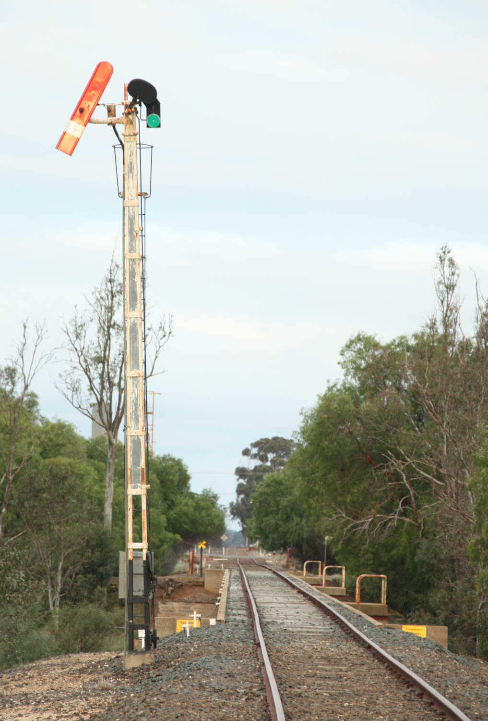
When I took these photos at Bridgewater in June 2016, it had been many years since a train had ventured down the Eaglehawk – Inglewood line. The line had been booked out in November 2009 due to track condition (washaways). However, the announcement of the standard gauge conversion of the Maryborough – Yelta line meant that the Eaglehawk – Inglewood line was rehabilitated, and it is expected to carry grain trains from the Manangatang and Ultima lines while the Maryborough – Dunolly – Inglewood lines are gauge converted. This is the Up Home at Bridgewater, with the Loddon River bridge in the background and the Bridgewater yard in the distance. The semaphore mast is of the welded batten type and appears to be a 25 foot mast. The electric lamp has been replaced by a reflective disc.

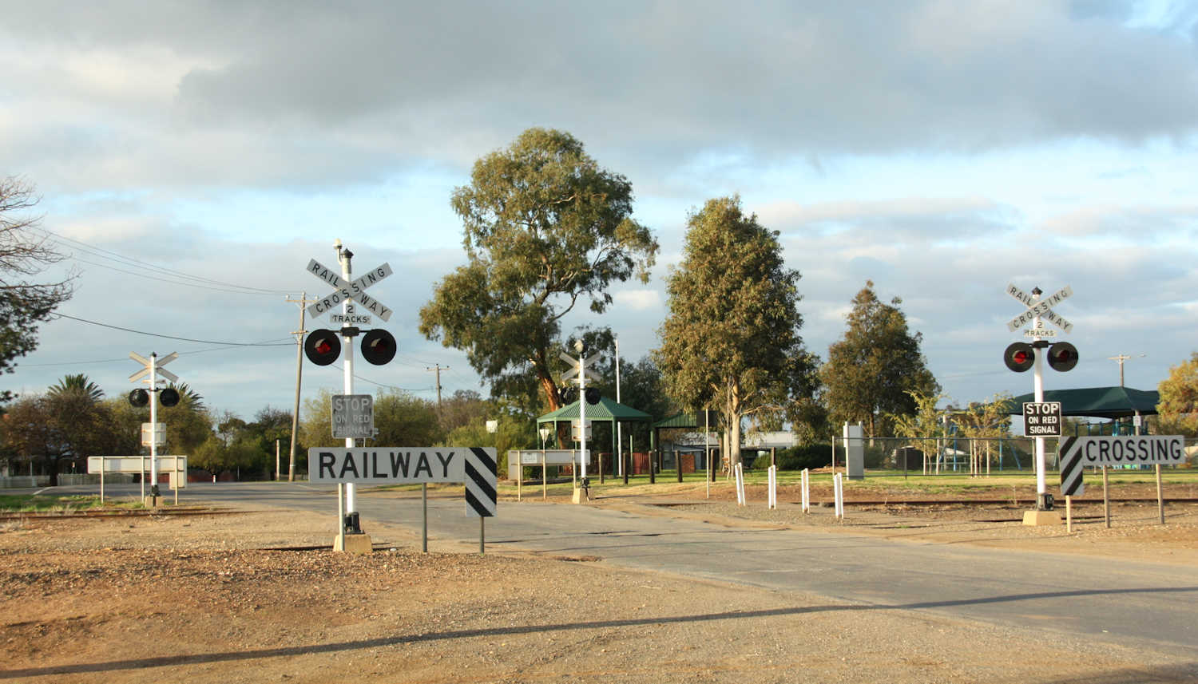
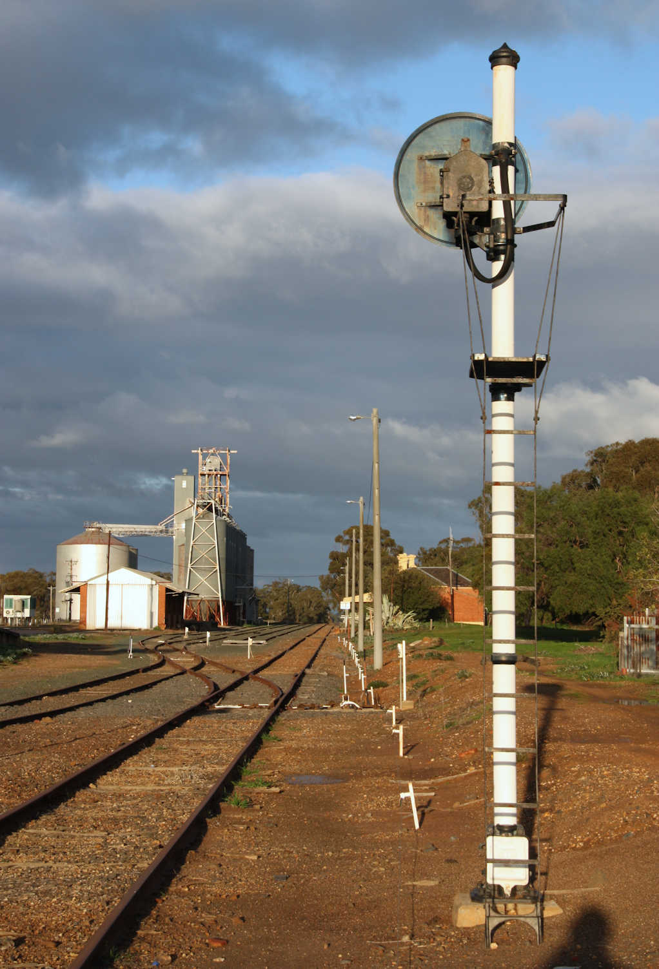
(Left) The Down end of the yard at Bridgewater, showing a rear view of the searchlight signal protecting the flashing lights at Lyndhurst Street. These searchlight signals were provided to prevent the flashing light signals from operating unnecessarily when a train standing on the approach track circuit. Several push buttons were provided to operate them – at least one on the platform and one at the points. In the case of Bridgewater, several additional pushbuttons are provided adjacent to the fouling points on the yard roads – the short vertical posts can be seen between the tracks in this photo. (Below) The flashing lights at Lyndhurst Street. Simple flashing light installations are also becoming less common in Victoria. This one is unusual as four masts are provided, possibly due to the width of the crossing. One mast (the second from the right, on the far side of the crossing) has the gong, and a second mast (the third from the right, on the near side of the crossing) has the healthy state indicator.

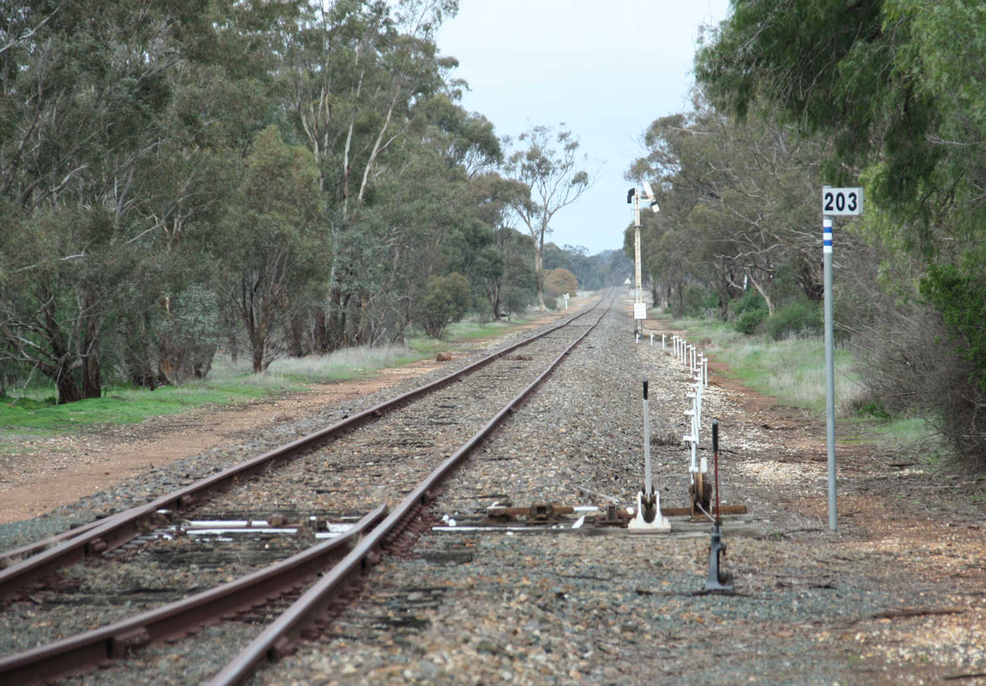
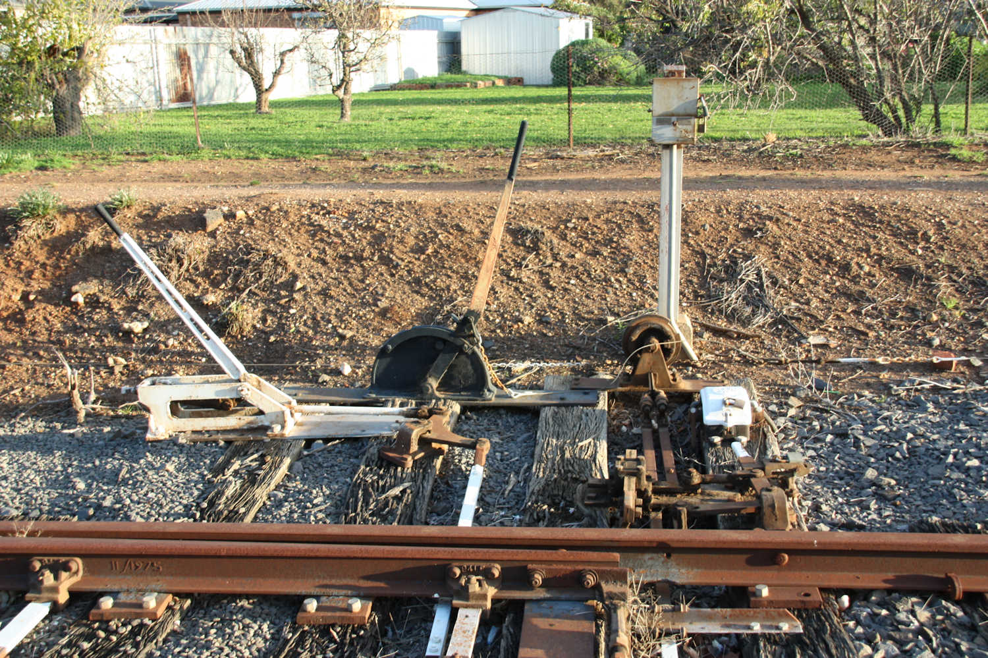
(Above) The plunger locked points D at the Down end of Bridgewater is a Y layout set of points with the plunger lock outside the ‘five foot’. (Below) The plunger locked points B at the Up end of Bridgewater are at 203 km from Melbourne, together with the Down Home in the background. The Down Home is 244 metres from the plunger locked points. The Home signal is solely worked from the tail quadrant in the foreground, the platform quadrant for this Home was removed in March 1985 when the points were relocated further out from the platform.

The station at Lydiard St was always officially ‘Ballarat’ in the timetables. However, it is notable that during the 19th Century, the local paper always referred to the station as ‘Ballarat West’, as did the Existing Lines and Traffic Branches. In this history, ‘Ballarat’ will be used.
Spelt ‘Macarthur’ today. Nineteenth century practice often used an apostrophe instead of ‘Mc’ or ‘Mac’.

